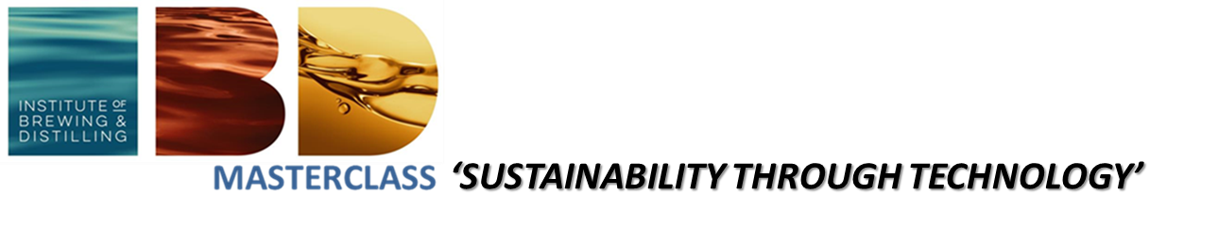
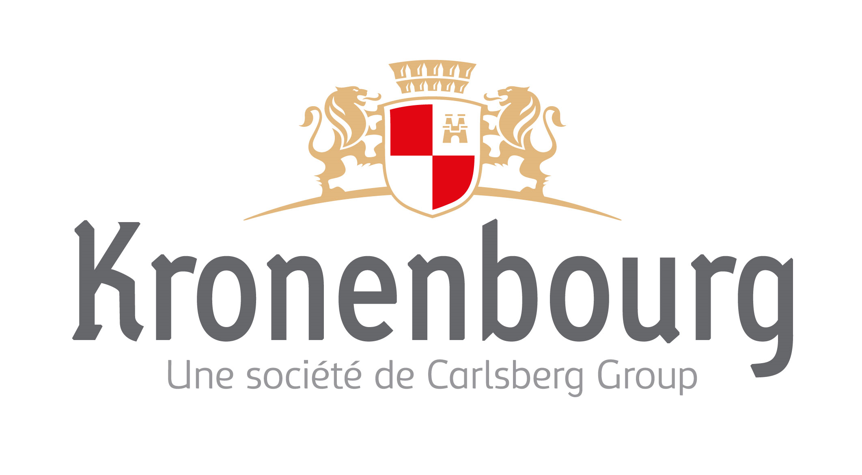
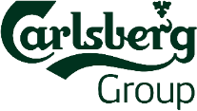
HOSTED BY

Making a positive impact on the world we live in - The IBD Masterclass Europe 2019
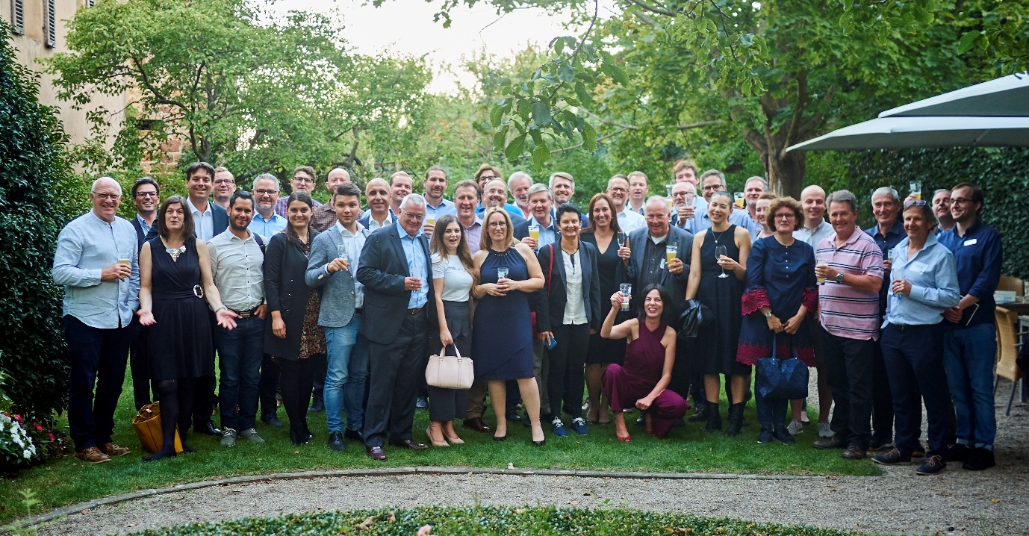
The IBD Masterclass Europe 2019 Attendees
The IBD Masterclass format is now in its 4th year has evolved into an impactful annual fixture to provide trusted knowledge to our members in Europe. The Masterclass format is designed as a short event (comprising of a welcome evening, a full day technical seminar and a half day technical visit) that delivers relevant knowledge around a hot topic of current interest to the industry. The principles of the IBD Masterclass can be summarised as:
- Quality, Quality, Quality speakers, content, technical visits, venues.
- Focus, Relevance and Impact a hot topic of current interest to the industry presented by the leading experts in that field
- Outside Perspectives from other industries and disciplines to bring new ideas
- Meaningful Interactions and Lasting Relationships: the size of event is limited to 100 attendees to create multiple personal touchpoints to facilitate meaningful discussions to create lasting relationships.

After the Masterclasses on “Quality” (2016, hosted by TUM Weihenstephan, Germany), “Sensory and Consumer Science (2017, hosted by Stiegl Brewery, Salzburg, Austria) and Innovation (2018, hosted by Pilsner Urquell Brewery, Pilsen, Czech) the 2019 Masterclass Europe was hosted by Carlsberg/Kronenbourg in Obernai, France.
The hot topic for 2019 was “Sustainabilty through Technology”. We are going through a sustainability revolution that rivals the agricultural and industrial revolutions in the way it will transform society. Innovation and creativity will be needed to develop radical, new products, and technologies that are less damaging to the environment and generate new businesses and jobs. In a nutshell: In a world of increasingly limited resources, how do we rethink what it means to win so that profit comes not from gaming the system but from changing the game for everyone? What does this mean for us brewers and distillers? How can our industries use technology to make a positive impact on the world we live in - our Environment, our Communities and People?

The IBD Masterclass Europe 2019 kicked-off with the welcome evening at a traditional Alsatian restaurant at the heart of the Obernai where old contacts were renewed, and new contacts made. The full day technical seminar was opened by Jerry Avis and Michaela Appelbee-Miedl on behalf of the IBD. Myriam Shingleton (Vice President Product Development at Carlsberg Group) welcomed the attendees on behalf of the host and presented the history and company profile of Carlsberg introducing the strategic importance of sustainability for the Carlsberg Group.
The tone for the event was set by the Keynote of Prof Rene Schmidpeter (Director and Chair of International Business Ethics and CSR, Centre for Advanced Sustainable Management (CASM) Cologne Business School, Germany) who is an international expert in sustainable management and sustainable business transformation. Prof. Schmidpeter works with the German car manufacturers on their sustainability journey. He demonstrated that success in terms of shareholder value is linked to environmental and social sustainability of a company. In other words – there is no trade-off between sustainability and economic success, but rather these variables are positively correlated. Scientific studies show that sustainable companies deliver higher shareholder value. Money markets have recognised that the Alpha (risk-adjusted return) of sustainable companies is higher than the market average and thus investors are systematically and at large scale seeking out sustainable businesses to put their money into. For too long there was a black and white debate between the shareholder maximising mangers on one side and the often dogmatic and moralising sustainability apostles. The new paradigm recognises that this constructed trade-off does not exist - sustainability and company success go hand-in-hand. Today there are countless examples of entrepreneurs that have created businesses that are highly profitable BECAUSE they are also sustainable. Young talent wants to work for companies where they can develop a successful career AND stay true to their values. The world is no longer seen as contradictions and trade-offs. Instead of thinking in scarcity and limitations this new breed of companies and people think in entrepreneurial opportunities that intertwine economic success and sustainability. To achieve this, it is not enough to manage a business based on the successes of the past. It requires that a company focusses on creating value for society and in doing so open up creative opportunity spaces to generate new business ideas fit for the future. As Prof Schmidpeter put it: “Companies must think the present from the future. It is possible to solve the biggest challenges of our time while at the same time finding business strategies that create added value for society and the economy.”

Simon Boas Hoffmeyer (Sustainability Director at Carlsberg Group) introduced the Carlsberg “Together Towards ZERO” program that was launched in 2017 and is its most ambitious sustainability initiative of Carlsberg to date. Simon talked about how the program was developed, as well as the effect it has had on the organization and society.
Håkon Langen (Packaging Innovation Director at Carlsberg Group) talked about Consumer relevant Sustainable Packaging. In 2018 Carlsberg launched several sustainable packaging innovations for the global brand Carlsberg. These are called “betterments”, tangible sustainable packaging solutions relevant for consumers. One of these is Snap Pack, a new multipack type for cans, with a new to the world technology developed in a collaboration with packaging material and equipment suppliers. The Snap-Pack received an overwhelming media interest and was very well received by customers and consumers.
Flo Vialan (Director of Brewing, Purity Brewing Co., UK) talked about “Brewing Beer with a Conscience – the Story of Purity Brewing”. He brought to live the journey starting from 3 men, a dog and a shed, to a UK leading craft brewery that has won, besides many awards for the quality of their beers, the Insider Made in the UK Sustainable Manufacturer of the Year Award in 2015 and the Midland’s Sustainable Manufacturer Award in 2016. Flo has also won the All Parliamentary Beer Group Brewer of the year 2017. Flo described how sustainability and brewing beer with a conscience is at the heart of Purity. Responsibility to the environment and local community is taken very seriously. The brewery uses the latest heat exchange and steam recapture technology to reduce energy consumption. The spent grain is fed to the Longhorn Cattle on the farm and to brewery Geese. The spent yeast is fed the local pigs and the used hops are used as fertiliser on the farm. The brewery recycles the wastewater by using a natural wetland system creating a thriving ecosystem ensuring pure water is going back into the water system. Beer is canned on site reducing beer miles and fuel use. Purity has made some huge sustainabilty strides for a small company, but the team is already planning the next projects.

Tiago Brandão (New Business Director – Beer & Brewing, Super Bock Group, Porto, Portugal) talked about “Talent as the Multiplier for a Sustainable Future”. Tiago made a compelling case by starting from defining Sustainability and what it means in the context of the brewing industry. He considered current key challenges in the brewing business and then proposed talent development strategies to build sustainable business models. What skills must talent have? What does technical thought-leadership mean and how can it help businesses to be sustainably successful? Where does talent like to work? How do we recruit and/or develop a solid talent pipeline? How do we retain it? The arguments made were underpinned by practical examples from Tiago’s personal experience and can be summarised as: “Success, whatever your business, is not about how well you MANAGE CHANGE in your Organisation, but how efficiently you ADAPT TO IT!”

Morag Garden (Head of Sustainability and Innovation, Scotch Whisky Association (SWA), Scotland, UK) outlined key sustainabilty initiatives of the Scotch Whisky sector in her talk “A Toast to Sustainability – The Journey of the Scotch Whisky Sector”. Morag provides an overview of the Scotch Whisky sector and its economic impact both in Scotland and globally. She outlined the environmental story and the sustainability strategy of the Scotch Whisky Industry emphasising an effective working relationship with Scotland’s Environmental Regulator as a key enabling success factor. Key successes were brought to live by case studies that showed how Scotch Whisky companies are delivering on the strategy far beyond compliance. Project DEEP, an initiative by Glenmorangie and partners works on re-creating oyster reefs in the Dornoch Firth after 100 years of absence. Further a technology cluster consisting of several innovative partner companies are working with the Scotch Whisky Industry on circular economy projects with the aim to up-cycle Scotch Whisky by-products and find new markets for them.

Tim Cooper (Managing Director and Chief Brewer of Coopers Brewery, Adelaide, Australia) talked about “Sustainability is OUR Business – The Story of Coopers Brewery and Maltings”. Today, Coopers Brewery is Australia’s largest independent brewery. Having relocated in 2001, Coopers Brewery at Regency Park is one of the most modern breweries in Australia, demonstrating a focus on operating with the least possible consequence to the environment. In areas such as energy recovery, power generation, water usage, recycling and efficient operation, Coopers has adopted world-best practices. Tim described the natural gas-powered cogeneration plant located on the brewery site to supply electricity and steam and thus reducing CO₂ emissions by up to 15,000 tons per year compared with a conventional power plant. Energy efficiency is further boosted by low grade heat recovery and reuse in the brewhouse. All water used by Coopers originates from an aquifer 190m beneath the brewery, reducing the demand on Adelaide’s reticulated water supply. In addition, Coopers captures and recycles up to 35 megalitres of water each year. In 2017, Coopers opened a malting plant adjacent to the brewery, producing around 54,000 tonnes of malt a year. Novel in-house designed features have reduced steeping times, water usage and kiln-gas during the malting process. The maltings use the surplus steam from the co-generation plant to pre-heat the kiln, resulting in an energy saving of around 40% of kiln gas. In response to the strong community support received during a hostile takeover bid in 2005, Coopers extended its community focus through the establishment of the Coopers Brewery Foundation. Since its inception, the foundation has raised more than $5 million from brewery tours, recycling activities, golf days, staff and stakeholder donations, with this money being donated to over 200 worthy Australian charities.

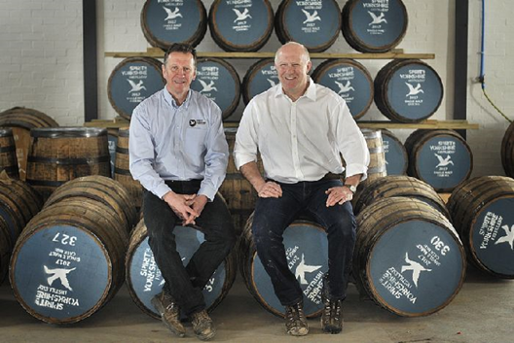
David Thompson and Tom Mellor (Directors and Co-Founders Spirit of Yorkshire Distillery Ltd, Hunmnaby, North Yorkshire, UK) presented a talk on "Respecting Tradition but Doing It our Own Way – The Story of the Spirit of Yorkshire Distillery."Tom and David are the co-founders of the Spirit of Yorkshire Distillery in Yorkshire, England. Yorkshire is known for many things, especially brewing and beer, but whisky isn’t one of them… yet. Here at Tom and David’s home on the Yorkshire coast they are making Yorkshire’s first single malt whisky, from field to bottle. The aim of the Spirit of Yorkshire Distillery is to not simply replicate what has happened before just because that is “the way it’s always been done.” The philosophy of “respecting tradition but doing it our own way,” is an ethos that is brought to life in all aspects of the business, from the stills, to the approach to whisky in the first place, to the kind of talent they look to employ. In the words of Tom and David: “We’re not challenging convention just because; we’re understanding the traditions of the industry and then working out how we can make it relevant to us, always with the ambition of creating a world-class world whisky. In the same vein, sustainability has never been our goal, in and of itself. Instead we’ve found it’s a natural and positive by-product of our progressive approach to farming, brewing and distilling.” Tom and David introduced the distillery, the background, philosophy, aims and ambitions, and then proceeded to talk in more detail three specific areas: our farm, our stills and our people.
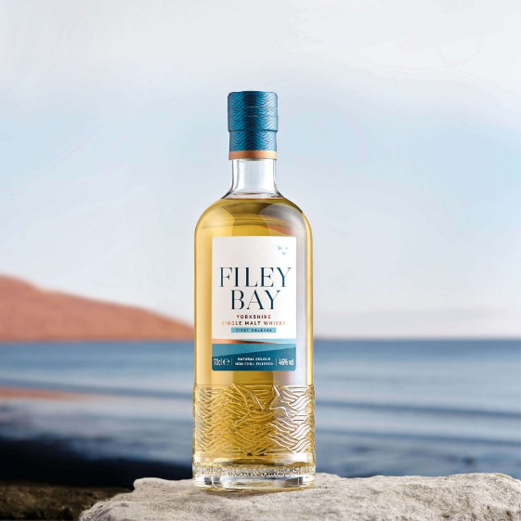
We concluded the technical seminar with a panel discussion facilitated by Prof. Schmidpeter and a tasting of the first expression of Yorkshire's first ever single malt. The attendees of the IBD Masterclass were privileged to be among the first people outside of the distillery to taste this whisky. The Filey Bay First Release by the Spirit of Yorkshire distillery combines the pot and column distillates and has been matured predominantly in first fill bourbon casks with a subtle sherry influence. The single malt is made from a selection of just 16 casks that were laid down in the spring and summer of 2016 yielding just 6000 bottles. The tasting revealed a spirit that is creamy, light and fruity, with flavours of vanilla, honey, citrus and caramel. A worthy conclusion of an inspirational seminar and the perfect aperitive for the seminar dinner.
The technical visit on the next day was to the Kronenbourg brewer and the Carlsberg Global Research Center in Obernai. Myriam Shingleton and her team gave us an in-depth tour of the Global Research centre with rich insights into areas such as innovation, product- and packaging development, sensory and consumer science and analytical set-up. The brewery tour was very informative with knowledgeable staff at hand to answer questions and beer tastings set up for us on the brewery premises. The technical visit concluded with a tasting of non-alcoholic products from the Carlsberg group portfolio.
We would like to thank the hosts Carlsberg and Kronenbourg as well as the sponsors of the event. Thank you! – without you the IBD Masterclass Europe would not be possible.

